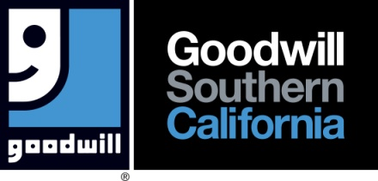

FOR IMMEDIATE RELEASE
Media Contact: Marla Eby
Director, Marketing & Media Relations
(323) 539-2104
meby@goodwillsocal.org

PRESS RELEASE

Goodwill Southern California Stores Are THE Destination To Find The Basics For DIY Ugly Christmas Sweaters

Los Angeles, CA, December 1, 2023 – It is holiday time and what is on everyone’s to-do list to prepare for the holidays? Purchasing Ugly Christmas Sweaters! The calendar change to December now requires a stop at Goodwill Southern California (GSC) stores to pick up the once-dreaded, now fashionable sweaters to wear to the office or family holiday party!

No longer are holiday sweaters tucked in the back of a closet, never to see the light of day. Ugly Christmas Sweaters are now highly sought after items, akin to finding this year’s popular toy. And Goodwill Southern California stores are THE place to find sweaters to use as a starting point to create DIY Ugly Christmas Sweaters.

Goodwill Southern California encourages customers to shop early if they plan to create Ugly Christmas Sweaters. “This time of year, customers snap up sweaters as soon as they are placed on the floor,” said Marla Eby, Goodwill Southern California’s Director of Marketing & Media Relations. “Shoppers then add ribbons, bows and embellishments to make them one-of-a-kind.”

When customers purchase items at Goodwill Southern California, they help thousands of individuals in our community with barriers to employment find jobs each year.

Shoppers can find a Goodwill Southern California store location by visiting our website locator at
www.goodwillsocal.org. With more than 80 locations in Los Angeles Riverside & San Bernardino
counties, there is a Goodwill store near everyone.

Media who wish to film at Goodwill Southern California’s stores may contact Marla Eby, Director of Marketing & Media Relations, at meby@goodwillsocal.org.

About Goodwill Southern California
Transforming lives through the power of work, Goodwill Southern California (GSC) serves individuals with barriers to employment by providing education, training, work experience and job placement services. Each year, GSC prepares and places thousands of individuals into sustainable employment through programs and services offered at three campuses as well as Career Resource Centers, WorkSource Centers, Youth and Veteran Employment Programs throughout Los Angeles (north of Rosecrans Ave.), Riverside and San Bernardino counties. GSC supports its mission with proceeds generated from more than 80 stores and additional freestanding attended donation centers. GSC spends 95 percent of its budget on programs and services. Committed to caring for the earth, last year GSC diverted over 130 million pounds of reusable or recyclable goods from landfills. Goodwill is GOOD for Everyone! Follow Goodwill SoCal on social media - @GoodwillSoCal or visit www.goodwillsocal.org for more information.

###

